### Ethan Horrigan

# Developer Diary

### One Life

[For best results when selecting text to copy or edit, don’t include space to the right of the characters in your selection. To replace the sample photo below with your own, just delete it. Then, on the Insert tab, click Picture]



09/10/2019

### Responsive Aspect Ratio

* Scale aspect ratio depending on device
* Preserve quality
* Lock to horizontal (16:9)

### Enemy Pathing Bug Fix

Enemy collision does not work when enemy pathing is enabled, to fix I need to rewrite the enemy pathing functionality to work with collision

Player Shooting – Raycast

Bullet “bounce”

Object Pooling

For Shooting mechanics I used Object Pooling instead of instantiating/destroying objects as this affected performance.

<https://www.raywenderlich.com/847-object-pooling-in-unity>

Using Ableton to Manipulate & Process sounds for sound effects within the game.

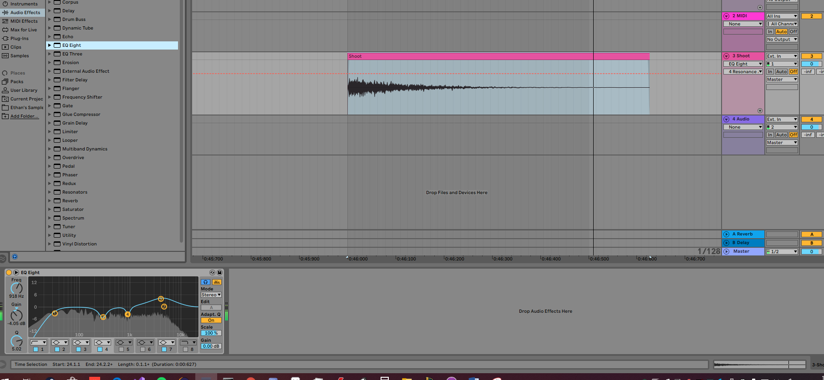

Using Asperite to create Sprites, Tilesets & Animations.

